Megha Dhawan

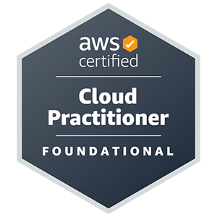 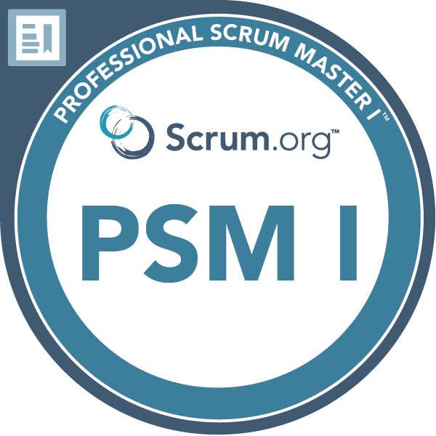

**Address**: 71 Oakway, Northgate, Crawley, WSX RH108HY

**Phone**: 07404529668, +447404529668

**Email**: [megha29dhawan@gmail.com](mailto:megha29dhawan@gmail.com)

Incident/problem Manager

**AWS, Microsoft Azure, ITIL & Scrum** Highly skilled and results-oriented Service Management Professional with extensive experience in Incident and Problem areas. Proven track record in leading and optimizing IT service operations to deliver exceptional customer satisfaction and business outcomes. Exhaustive experience in supporting projects for multinational clients in the Finance, Insurance and Banking, E-Commerce, and airline sectors. Complex problem solver able to thrive in fast-paced and challenging roles.

Skills

* **Cloud Computing:-** AWS, Azure
* **Database:**- Microsoft SQL Server | Oracle | MySQL
* **Operating Systems /Servers:-** Windows | iOS | UNIX | Linux | Ubuntu | CentOS | Tomcat
* **Languages:-** C | C++ | C# | .Net | ASP.net | Java | T/SQL | SQL | PL/SQL
* **Web Technologies:-** HTML | XML | JavaScript | CSS |
* **Monitoring Tools:-** Grafana | Kibana | PagerDuty | Splunk | SiteScope | AppDynamics | Dynatrace |
* **Ticketing Tools:-** Jira | Remedy | **Service Now** | Zendesk
* **Documentation and Reporting:-** Office 365, MS Word, MS Excel, MS PowerPoint, **Power BI**
* **Networking:-** DNS, SSH, IP addressing,Azure Monitor, Monitoring Agent

**Certifications**

* 2023 – AWS Cloud Practitioner Certified – CFL-C01
* 2022 - Microsoft Azure Administrator Certified - AZ-104
* 2021 - Microsoft Azure Fundamental Certified - AZ-900
* 2019 - Scrum Certified
* 2015 – ITIL v3 Certified
* 2014 – Prince2 Certified
* 2007 - SharePoint 2007 Certified

Accomplishments and Awards

**Honoured with:**

* On the Spot Award for best customer experience in - 2022 (TCS)
* On the Spot Award for best customer experience in - 2019 and 2020 (TCS)
* On the Spot Award for outstanding contribution to Organisation - 2017 (TCS)
* Promoted as Assistant Consultant in - 2015 (TCS)
* Service and Commitment Award - 2013 (TCS)
* On the Spot Award for Excellent work to Deliver a critical change for the client - 2012 (TCS)
* Service and Commitment Award – 2011 ( TCS)

Education

* 3 Years Bachelor’s Degree in Computer Engineering, 2007 with 70% (B.E)
* 3 Years Diploma in Computer Science 2003 with 72.33%
* Matriculation from Central Board of Secondary Education in 2001 with 72%

Work history

* Tata Consultancy Services, UK

**Role – Incident/Problem Manager 03/2021 to Current**

**Client - Legal and General:** For over 185 years Legal and General has provided financial services to customers across the UK. They are now a global provider of retirement solutions to corporate and individuals, and skills lie in asset management and origination, longevity risk and technological innovation.

**Profile/Responsibilities:**

* **Point of Contact for all Major/Minor Incidents.**
* Monitor the incidents to ensure that the Service Level Agreement are respected.
* **Identify, initiate, schedule and conduct incident reviews.**
* **Schedule technical bridge, and document key actions and events during conference calls.**
* Investigating, analysing and contributing to the **post-review of Major Incidents** in order to facilitate the resolution of complex and interrelated business issues and problems.
* **Exhaustive experience in Incident/Problem/Change functions**, Act as cover for the Incident and Problem Manager, to chair incident and problem review meetings to ensure decisions and actions are taken and followed up.
* **Performing incident trending** to identify proactive problem records. Managing with resolver teams to ensure correct processes are followed to identify and implement root cause fixes.
* Ensuring consistent known error information is maintained and reviewed.
* **Escalating incidents and request ite**ms based on urgency against existing SLAs. Analysing data and making recommendations for prevention.
* Maintaining incident and problem process documents for use in the Group Functions business area. Advertising, monitoring, and enforcing the processes with the support teams.
* Monitoring trends in Problems and Major Incidents to identify issues in performance, availability, and capacity.
* Ensure the closure of all resolved and end-user-confirmed Incident records.
* **Worked closely with change management and where applicable correlated incidents to requested changes.**
* **Client focused**. Have developed a culture within my team to have that same mentality that also extends to our internal user base.
* **Represent in the first stage of escalation for Incidents.**
* **Provide business impact updates to stakeholders** and leadership as required (in verbal and written form).
* Participate and help drive root cause analysis meetings to identify underlying causes of major Incidents, whilst ensuring all vital preventative or risk mitigating actions are collected and progressed with internal teams through to completion.
* **Collaborating with multiple teams both within operations and our account management groups to have adherence to major incident management processes and taking feedback in order to better support those groups in times of major incidents.**
* Preparing documentation and reporting for the executive team on a weekly, monthly and quarterly basis using **ServiceNow tools and PowerPoint, Power BI presentations.**
* Significantly improved how incident communication is distributed externally and internally. As well as how to reason for **outage reports is managed and released.**
* Provide **on-call Incident management cover** on a rotational basis to handle all major incidents outside of business hours.
* Matrix management of people, processes and resources including third parties – including resolving conflict to move forward to resolution
* Responsible for the effective implementation of the process "Incident Management" and carries out the respective reporting procedure.
* **Develop and maintain incident response plans and procedures.**
* Review the initial classification **(including priority) and categorization of the Problem Record.**
* Lead and manage both **proactive and reactive Problem investigations via Root Cause Analysis**
* Ensure that cross-service provider **(Client, 3rd Party and Partner contacts) problem investigations are conducted effectively and in line with end-to-end Service Level Agreements**
* **Ensure that active knowledge sharing exists between** all engaged parties, ensure mandatory compliance with and ongoing maintenance of the Known Error database and promoting it across service providers and Service Domains
* **Tracking open Problems and identifying any Problem that requires increased focus to meet agreed target levels**
* **Handling day-to-day Problem issues and escalating to Resolver Groups when required to ensure targets are met**
* Run and Manage Numerous Problem Management related reports
* **Chair problem and Incident Management review meetings in order to identify the root cause and preventative fixes as well as determine the suitability of proposed/in-place workarounds**
* Implement a mechanism to record **Known errors** within the account and the associated workarounds.
* Tata Consultancy Services, UK

**Client - Legal and General, UK**

Role – Incident/Change Manager, 06/2020 to 11/2021

**Introduction:** For over 185 years **Legal and General has provided Banking and financial services to customers across the UK**. They are now a global provider of retirement solutions to corporate and individuals, and skills lie in asset management and origination, longevity risk and technological innovation

**Profile/Responsibilities:**

* Resolving and mitigating all the production issues for **Finance application within SLA.**
* Working on finding the root causes for the reported issues and applying permanent fixes.
* **Gathering high-level technical requirements** by proposing descriptions associated with **existing product/platform capabilities** to minimise client risk and promote standardisation.
* **Implemented and executed Incident Management Processes** for client including invocation, ownership, escalation, communication and restoration of service.
* Advise customers on **technical implementation, help them resolve their issues, and carry** technical feedback to **Product and Engineering teams.**
* Provided change approvals by **assessing risks ad impacts.**
* Reviewing all implemented **changes to ensure that** they have met their objectives as well as referring backany that have been backed out or have failed.
* Coordinate with all necessary parties to perform change planning, testing and implementation in accordance with schedules.
* **Review the FSC and prioritise as required, organise Change Review boards if applicable to facilitate the preparation and assessment of RFC's**
* Support the operational management of all types of Change and Release CRQs via Remedy/SNOW and the process for Customer
* Support Project teams to ensure **Change management procedures** are incorporated into their plans for new solutions and services
* **Ensuring RCAs** are completed for all Failed changes.
* **Support ISO compliance procedures and audit activities annually.**
* **Ensure the change management process is clearly communicated**, understood, and adhered to by stakeholders.
* **Maintaining oversight of changes to ensure they are planned effectively and change owners have considered all requirements to** ensure safe delivery.
* Creating a dashboard using **Power BI, Service Now.**
* **Attending Daily Cab, Sprint calls, Backlog refinement calls, Technical Cab** meetings and Demand Pipeline meetings to understand changes scheduled and planned for the future.
* Tata Consultancy Services, UK

**Client - Virgin Atlantic Airways**

Role – Team Lead/Scrum Master, 05/2014 to 05/2020

Technology Used: SQL Server 2005/ Unix/Linux/**SharePoint**

**Introduction:** Virgin Atlantic, a [trading name](https://en.wikipedia.org/wiki/Trade_name) of Virgin Atlantic Airways Limited and Virgin Atlantic International Limited, is a British airline with its head office in [Crawley](https://en.wikipedia.org/wiki/Crawley), England.

**Profile/Responsibilities:**

* Single Point of Contact (SPOC) for all communications between customers, clients and team members.
* Conducting Daily stand-up call with team to understand the work in progress, completed and blockers
* SiteScope monitoring set-up, Splunk alert/dashboard set-up
* **Writing SQL queries to resolve database issues for user-reported tickets/issues.**
* Identifying, monitoring and automation opportunities and implementation
* Participating in ticketing tool enhancement and deployment (Jira, Service Now)
* Setting up calls with users for requirement analysis & working with the development team to lower the issues/tickets flow
* **Dealing with users/clients and resolving problems**, issues and making sure SLA's are met
* Conducting regular impact analysis to assess the project deliverables' consequences on other sections of the business.
* Arranging weekly application support call with a client for the progress measurement and **new requirement, implementing process improvements** and participating in daily/weekly team meetings for targets &achievements of the ticket SLAs
* Working on achieving high standards and KPI targets; recruiting new staff members
* Resolving extract, transform, and load (ETL) procedural failures and automating ETL process by writing shell scripts.
* Setting up new alerts and dashboards in SiteScope, Splunk and Dynatrace.
* **Fostering a positive working environment within the team**
* Providing prompt and accurate information on individual performance
* Collaborated with users to reduce the quantity of issues, enhanced the performance of ticketing tools, and mentored team members in drafting SQL queries to resolve database issues.
* Mentoring and training junior and new staff
* **Removing project impediments** that stand in the way of team productivity and performance
* Helping the development team to create high-value products
* Ensuring the development team is working effectively, by conducting regular reviews
* Creating transparency in processes and resolving conflicts
* Helping the team to understand and follow the goals, scope of work and product domain
* **Facilitating Scrum events as requested or needed**
* Tata Consultancy Services, UK

**Client - Virgin Atlantic Airways**

Role – L2 (CMS) Production Support analyst, 06/2008 to 04/2014

**Technology** **Used: SQL Server 2005 / SQL Server 2008/ Tridion/SharePoint**

**Introduction:** The content of the Virgin Atlantic website was hosted Tridion/SharePoint Web content Management system. This solution enables organisations to deliver a consistent, interactive and highly targeted customer experience, in multiple languages, across multiple websites and channels including email, mobile sites and print.

**Profile/Responsibilities:**

* Manage the content on public websites and intranet portals.
* Analysed, debugged and resolved application problems and system issues
* Created and updated SharePoint/Tridion user groups and accounts.
* Participated in site migrations and designed content management solutions.
* Designed and managed content management templates and work flows.
* Troubleshot and resolved application issues escalated from end users.
* Ensures that all content is accurate, well-crafted and aligns with brand strategy.
* Troubleshoot and resolve content migration errors.
* Review and update missing content, images, links and other information impacting the user experience or search engine optimization.
* Solving the escalated issue from L1 and L2. Solving customer queries according to SLA.
* Ensuring that backup and recovery procedures are functioning correctly.
* Installation, configuration and upgrading of SQL Server 2005/2008.
* Installing service pack and Security patches for SQL Server 2005/2008.
* Creating users, logins, roles; Password reset for SQL server users.
* Take care of Disk Space Alerts for Data Drive, Log Drive and Temp Drive.
* Server Monitoring.
* Writing Oracle/SQL Queries, Scripts for various Prod Issues for Virgin Atlantic Website
* Deployment of various projects (Migration of website toTridion5.2 to 5.3)
* Managing Service Now and tracking ticketing tools for production issues.
* Handling new client enquiries and acting as the face of the business
* Handling requests requires for user account creation on Tridion/SharePoint Application
* Performing Production / Non Production Testing on TEST/Prod server
* Interaction with Business users for bug fixes and Enhancements. Involved in application migration.
* Arranging weekly application support calls with a client for the team progress, new requirements.
* Arranging & chairing daily/weekly team meetings for targets & achievements of the ticket SLA's.
* Dealing with and resolving problems, issues and making sure SLA's are met.